Command Line

Shortcuts:
ls | Lists all the files in your current directory/location
pwd | Print Working Directory command.  Displays your current folder location from the root.
Ctrl + A | Set the cursor back to the start of the command line
Ctrl + E | Set the cursor to the end of the command line
Ctrl + U | Erase the commands in the line
Alt + Mouse Click | Set the cursor wherever in the command you like to edit it.
mkdir | Make Directory.  Create a New Folder
cd | Change Directory
cd ../ | Go back one directory
touch | Create a new file.  Sample: touch [Name of File].[extension]
Windows: start  MAC: open | To start/open a file.  Sample:  $ start –a Atom Text.txt  The “-a” means application. So you are opening Text.txt via Atom.
rm | Remove/delete a file or folder.
* | Wild card  Sample:  rm *  Removes all the files in the current folder.
-r | Allows you to remove a directory  Sample:  rm –r Angela/  Remove/delete the Angela folder including its child folders and files.
-rf | Allows you to FORCE remove a directory.  Force meaning it will not ask a confirmation from the user.  Sample:  rm –rf Angela/
sudo | Super Users Do
ls –a | Show all the hidden files in your current directory

VERSION CONTROL USING LOCAL GIT REPOSITORY AND THE COMMAND LINE

Vim – a text editor within the terminal
Open Vim: vim <file_name>
Save and Exit: esc + :wq

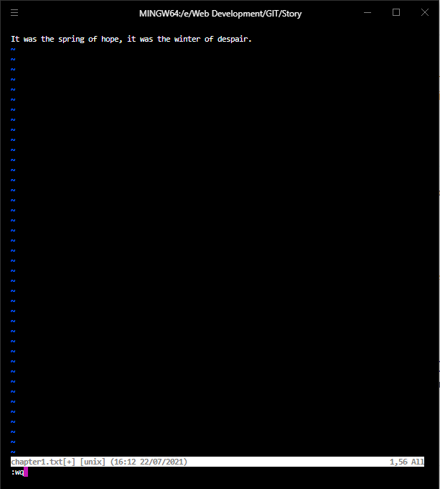

git init initialize an empty git repository inside your current Directory.
Once git is initialized, your current Directory will be called the Working Directory.

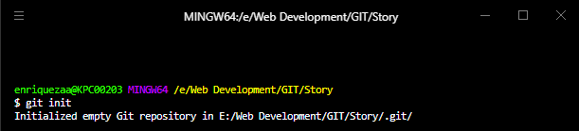

you cannot see /.git/ repository since it is hidden
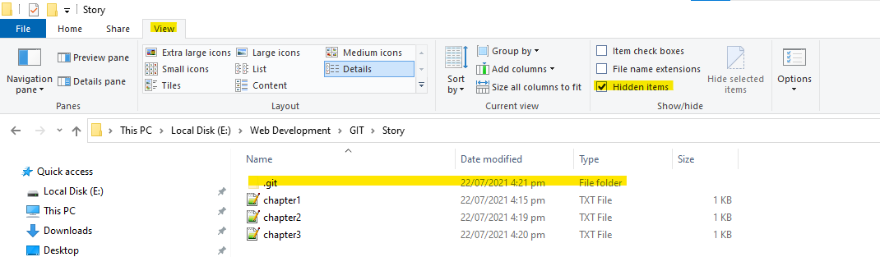

Or you can type in ls –a to view all the hidden files inside your current directory.
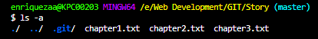

TRACK THE CHANGES OF YOUR FILE
You need to add your file to the Staging Area first before you can add your files to the Local Repository.
Staging Area is an intermediate place where you can pick and choose which files inside your working directory you want to commit.

git status to show you the untracked files (shown in red font color) you have in your Working Directory

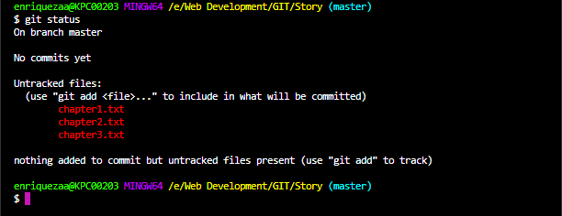

chapter1.txt, chapter2.txt, chapter3.txt is still simply in the Working Directory / Untracked Files but NOT YET in the Staging Area.

ADDING TO THE STAGING AREA
git add <filename> for specific files
or
gid add . for all files in the current directory

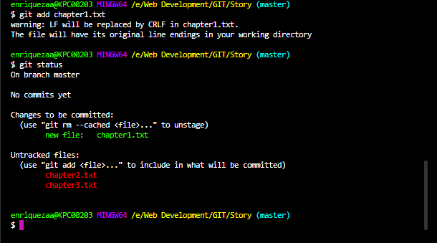

chapter1.txt is now in the Staging Area
chapter2.txt, chapter3.txt are still on the Working Directory.

REMOVING FILES FROM THE STAGING AREA
git rm –cached –r . removing all files in the staging area

COMMIT THE FILES UNDER VERSION CONTROL
git commit –m “<version/commit messages>”

best practice is to write your commit messages in present tense

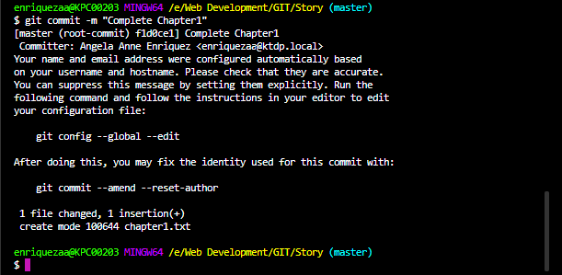

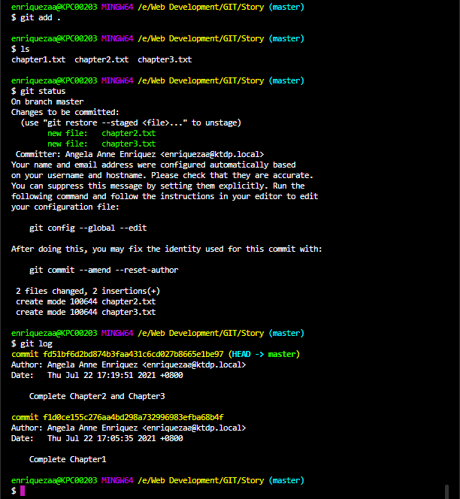

REVERT / CHECKOUT THE FILES THAT WERE SAVED IN YOUR LOCAL REPOSITORY
Previously, we have successfully saved chapters 1, 2, and 3 to our local repository. When we made some changes to Chapter3.txt we will see that it needs to be committed again.
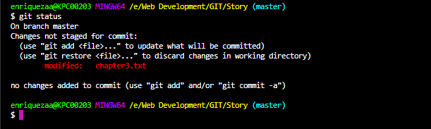

git diff <filename> to get the difference between the current file and the last safe point in the GIT repository.
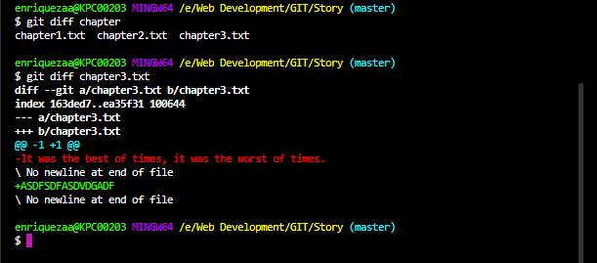

git checkout <filename> to checkout and overwrite the file’s last saved GIT repository

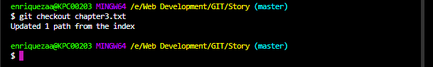
If you check Chapter3.txt again, it will show you the latest saved GIT repository file.

GITHUB AND REMOTE REPOSITORIES
Adding/pushing your files to a remote repository (using GitHub).
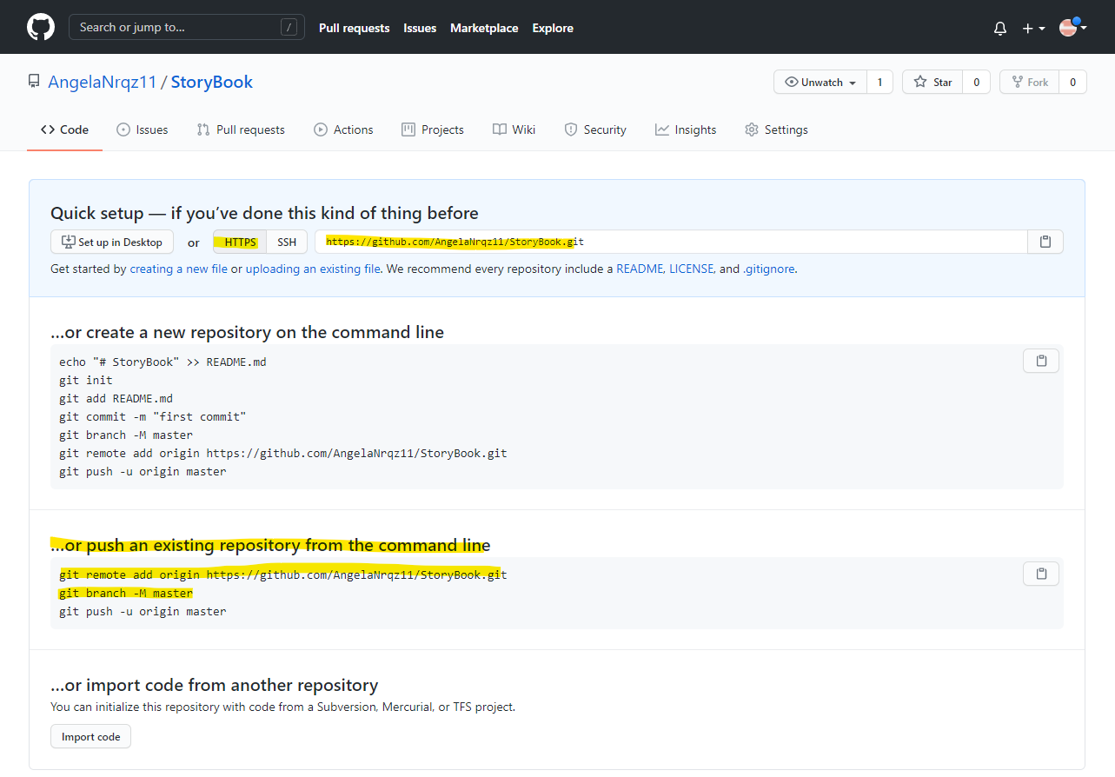
- Create a repository in GitHub.
- Copy the HTTPS address of your GitHub repository.
- Push/transfer your existing local repository to GitHub using these 2 lines of code:

Creating a Remote:
git remote add origin <url of your remote repository in GitHub>

Telling your local Git repository that you’ve created a remote repository over somewhere in the internet (in our case, GitHub) and want to transfer all of your commits there.

“origin” is simply the name of your remote and is called “origin” for naming convention.

git push -u origin master

This pushes your local repository using the “u-flag” (-u) which links up your remote and your local repositories. And then we’re going to push it towards the remote (origin) and then we’re going to push it towards the branch called master.

The master branch is basically the default branch or the main branch of all your commits in your remote repository. It is your main branch of commits or save points. It is sequential (timelined) and is usually where your main progress is saved and committed.

The Local Repository and Remote Repository can be completely parallel with each other, can be synced. The Local Repository is the .git file inside our PC directory. The Remote Repository is the Git directory we’ve got inside GitHub.

Example:

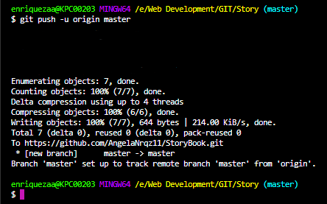

Refresh your GitHub page then you’ll see your repositories posted.
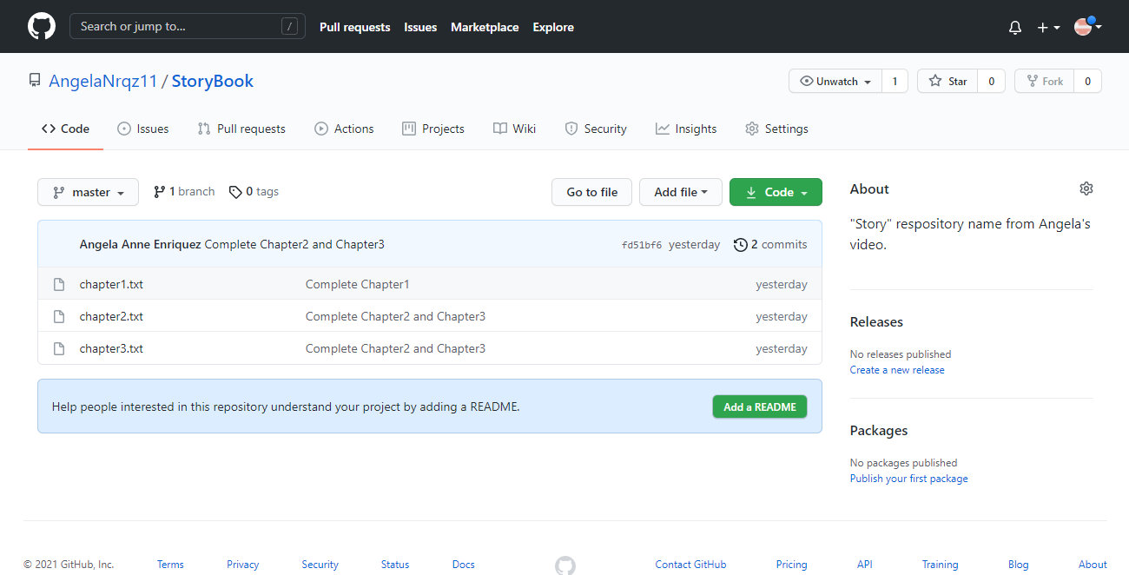

GITIGNORE
Hosting your files in GitHub can be cloned or downloaded by another user. But for security reasons, you don’t want some of your files to be committed to the Git.

Files Commonly Listed for GitIgnore:
- .DS_Store – is a file that stores custom attributes of its containing folder, such as the position of icons or the choice of a background image.
- Files that contain API keys, passwords, etc.

How to add files for GitIgnore:
- Create a file name:
$ touch .gitignore
- Specify the file name (case-sensitive) on each and every new line.
# (pound sign) – for comments
* (wild card / asterisk) – ignore all of the files with a specific file extension.

Example: *.txt ignore all files with a .txt extension.
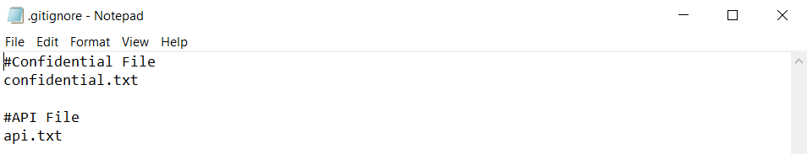
- Save the .gitignore file
- Add all files to the Staging Area.
$ git add .
- Perform Git Status to check if the files listed under .gitignore is NOT included.
$ git status
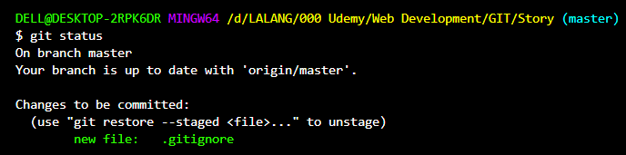
Chapter1.txt, chapter2.txt, and chapter3.txt were already committed leaving only .gitignore for add.

GIT BRANCHING
git branch To check what branch you are currently on.
git branch <new branch name> To create a new branch.
git checkout <branch name> To switch to another branch.
git merge <branch name> Merge the Branch changes to the Master branch.

FORKING
Forking happens when someone grabs a copy of your remote repository (from GitHub) and copies it to their own remote repository.
It is simply making a copy/duplicate of a remote repository and putting it under your own GitHub account.

PULL REQUEST
After forking a remote repository from another user (owner), and for instance the user will add some of its own changes and wants it integrated with the original owner’s remote repository it will need to send a “Pull Request”. The Pull Request is a request from the user to the original owner of the cloned remote repository for their changes to be added. The owner can then review the changes and decide to include the changes to its own repository. If approved, the owner will merge the cloned repository together with their own repository.

Pull Request isn’t called “Push” Request since you don’t own the rights to write on the original remote repository.

